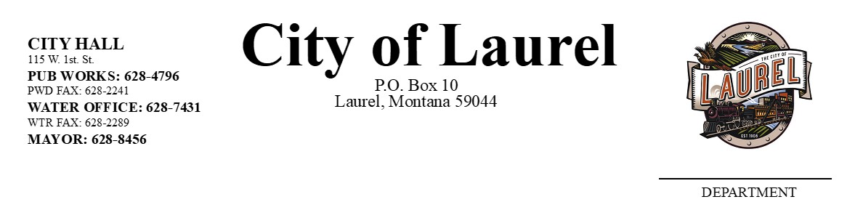

JOB DESCRIPTION

Criminal Prosecutor for the City of Laurel
(Half-Time Position)

UPDATED June 2024

Salary Range:

$65,000-$80,000 TBD

Salary at hiring will be dependent upon the applicant's education, experience, and training.

Compensation includes an excellent benefits package, with paid holidays, vacation, personal leave, health and dental, and disability coverage election.

Work Schedule:

Part-time (approx. 20 hours per week).

Hours dependent upon scheduling in court/remaining working hours to be set by Prosecutor.

Job Summary:

Represents the City in criminal proceedings as assigned before the Laurel City Court; investigates, prepares, and prosecutes misdemeanor criminal cases; and advises City departments, staff, and boards on criminal legal issues.

Essential Duties and Responsibilities:

Legal:

- Represents the City by prosecuting various misdemeanor criminal offenses; initiates prosecutions; prepares cases for prosecution; reviews reports and conducts legal research; prepares court orders, petitions, affidavits, and briefs; tries cases; determines and recommends appropriate sentences.
- Prepares pleadings, conducts legal research, prepares briefs and memoranda, appears in court, and negotiates with other parties.
- Prosecutes, negotiates, and settles misdemeanor criminal cases.
- Provides legal advice and opinions as requested by the Mayor to City employees, City Council, and City boards and commissions on a variety of criminal legal issues; conducts ongoing legal research in connection with criminal legal issues pertaining to the City.

Department Duties:

- Participates in the development, planning, and implementation of criminal policies and procedures for the City; devises and implements systems and forms for most efficient operations as assigned.
- Responds to and attempts to resolve difficult and sensitive citizen inquiries and complaints that relate to criminal matters within the City.

Performs other duties as assigned.

Qualifications and Skills

Required Qualifications and Skills:

- Juris doctorate from an American Bar Association approved law school
- Member in good standing with the Montana State Bar
- License to practice law in the State of Montana

Applicants must be currently authorized to work in the United States on a full-time basis.

Physical Demands and Working Conditions:

Work is a normal office environment. Intermittent effort involving lifting of amounts between 5 and 25 pounds is required. Work requires high attention to detail and deadlines between 45% and 70% of the time. Case-load varies.

Requirements are representative of minimum levels of knowledge, skills, and experience required. To perform this job successfully, the worker must possess the abilities and aptitudes to perform each duty proficiently.

This document does not create an employment contract, implied or otherwise. The City retains the discretion to add duties or change the duties of this position at any time.

